**Alex’s Analytics**

d

David Doman

IST 659

**Summary**

Alex’s Analytics is a new company specializing in sports analytics with the goal of being able to predict outcomes of high school football games in the Pittsburgh area. Being in the very early stages, the CEO and founder of the company wants to first start with designing and structuring a data model. While the initial data design will be very basic an initial foundation needs to be created in order to build and grow data model. The first phase will include defining the entities and relationships by determining business rules, providing a data glossary, identifying the questions we would like to answer and displaying a conceptual and logical model.

**Stakeholders**

The stakeholders for this endeavor include the CEO, stats reporters, the football teams and football fans, who live for high school football in the Pittsburgh area. As of now, various stats reporters attend games and record the stats from the games. Each reporter records stats in their own fashion, for example, some write the stats down with paper and pencil and others will record stats on a laptop. Being able to implement a database to store and make this data readily available will allow for the company to accumulate and analyze the data in order to make predictions on who will win game. Another advantage of being able to store this data in a database is to be able to compare teams’ performances from year to year.

**Business Rules**

* A team plays many games.
* More than one team plays a game.
* A stadium hosts many games.
* A team produces many stats.
* A game produces many stats.

**Glossary**

A **Team** is the one who plays in a game.

A **Stadium** is the venue a game is played.

A **Game** is played by 2 teams in a stadium.

A **Home Team** is the one who hosts the game in their stadium.

An **Away Team** is the one who plays in the Home Teams stadium.

A **Game Date** is the date for which a game is played.

A **Stat** is a measure of performance by a team.

A **Rushing Touchdown** is a way to score points by running the ball.

A **Passing Touchdown** is a way to score points by passing the ball.

**Total Points Scored** is an amount achieved by a team at the end of a game.

**Total Points Allowed** is an amount scored by the opposing team.

A **Win** is when Total Points Scored is greater than Total Points Allowed in a game.

A **Loss** is when Total Points Scored is less than Total Points Allowed in a game.

**Data Questions**

* Which teams have the best Total Points Scored to Total Points Allowed Ratio?
* Which teams have the most Passing Touchdowns?
* Which teams have the most Rushing Touchdowns?
* Which Stadium has the most points scored in it?
* Calculate Points scored when a team is Home VS. Away

**Conceptual Model**

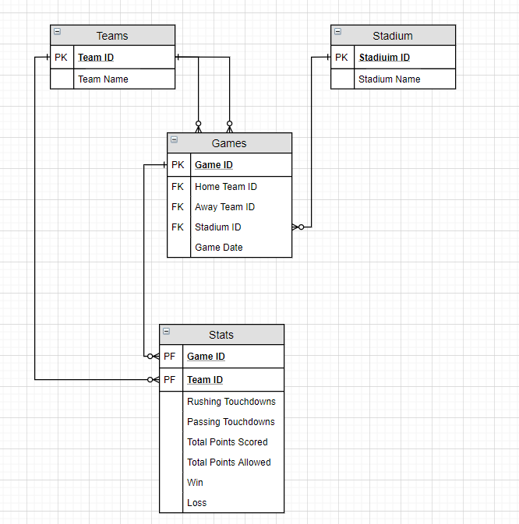

**Logical Model**

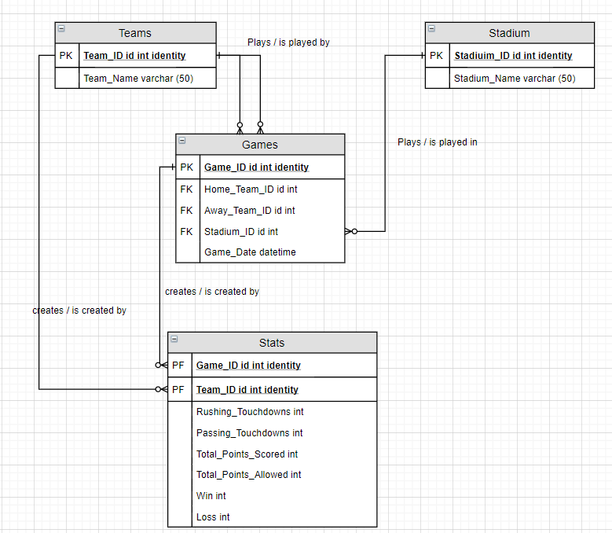

**Raw Data Sample**

|  |  |  |
| --- | --- | --- |
|  | **Home Team** | **Away Team** |
|  | Upper Saint Clair Panthers | Mount Lebanon Blue Devils |
| **Final Score** | 30 | 24 |
| **Total Rushing Yards** | 123 | 89 |
| **Total Passing Yards** | 310 | 323 |
| **Win/Loss** | W | L |
|  |  |  |
|  |  |  |
|  | **Home Team** | **Away Team** |
|  | Bethel Park Blackhawks | Peters Township Indians |
| **Final Score** | 24 | 13 |
| **Total Rushing Yards** | 75 | 64 |
| **Total Passing Yards** | 240 | 176 |
| **Win/Loss** | W | L |

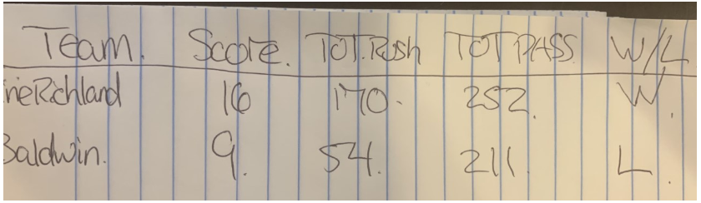

**Physical Database Design**

**--Screenshots from SQL**

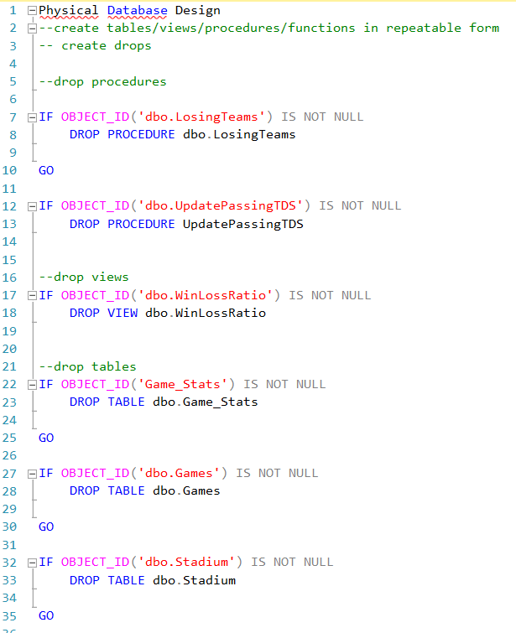

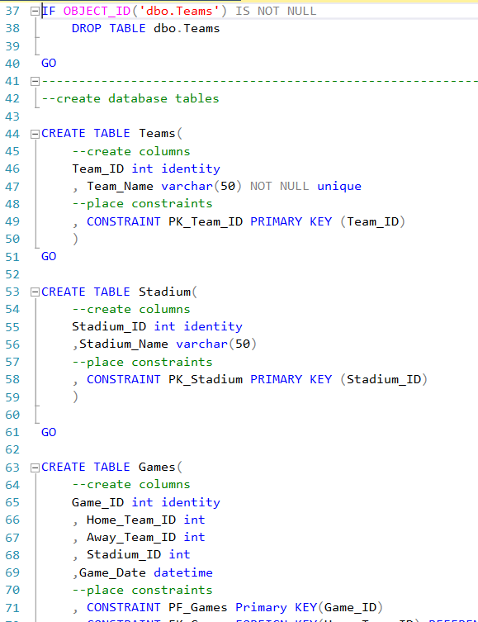

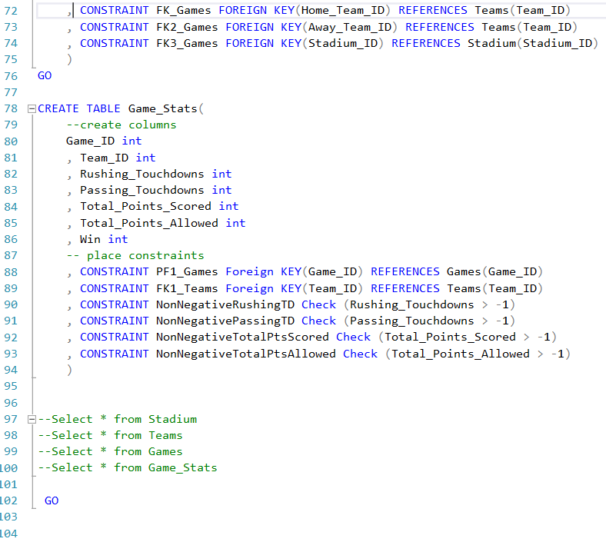

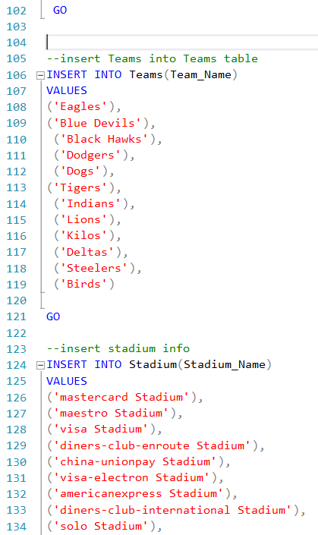

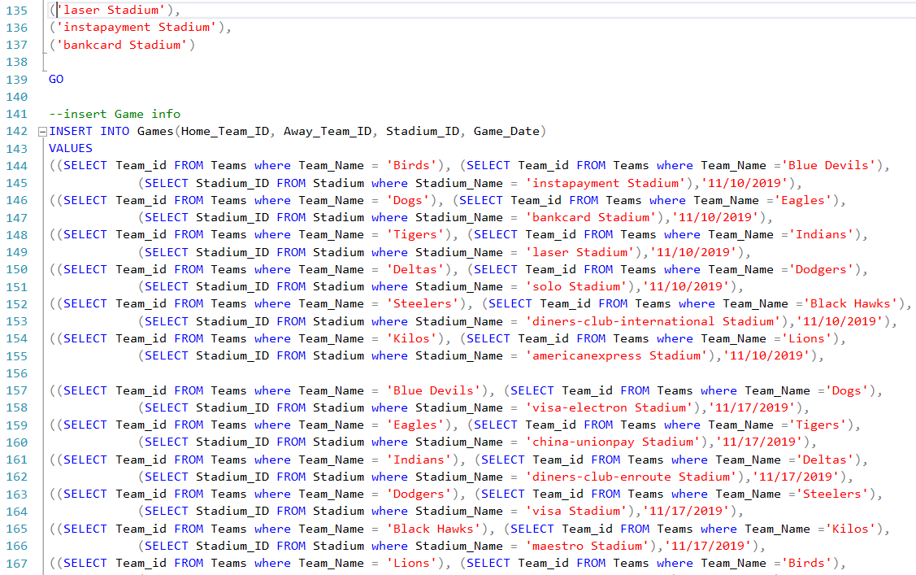

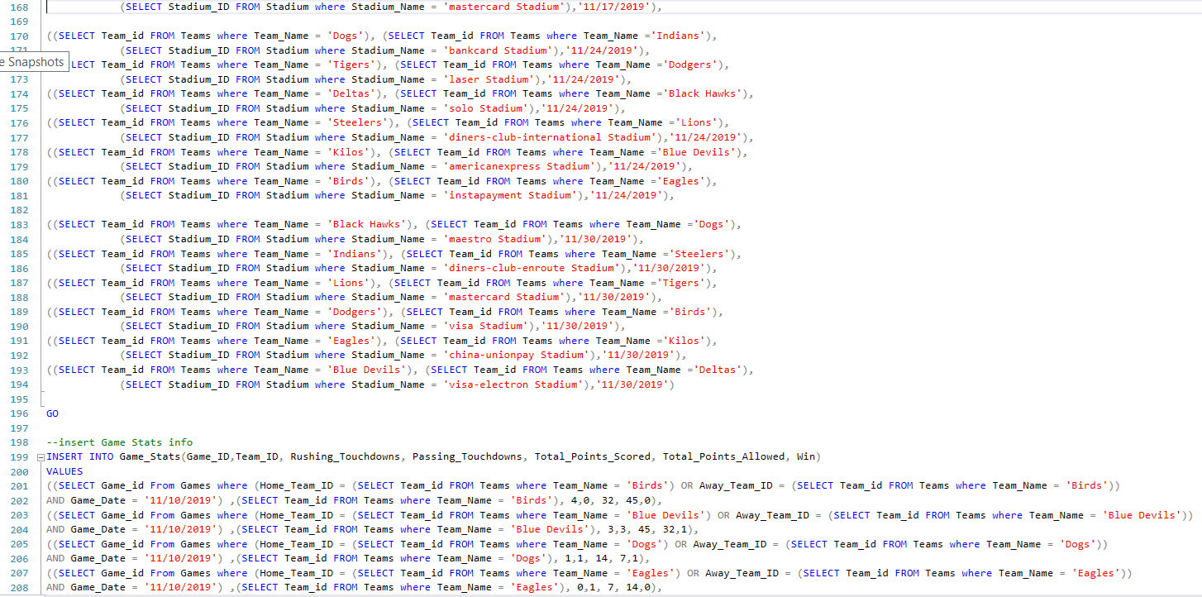

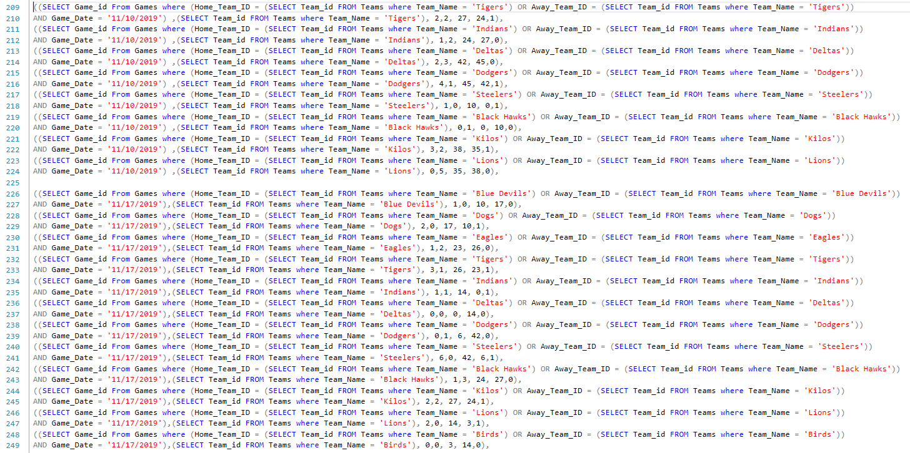

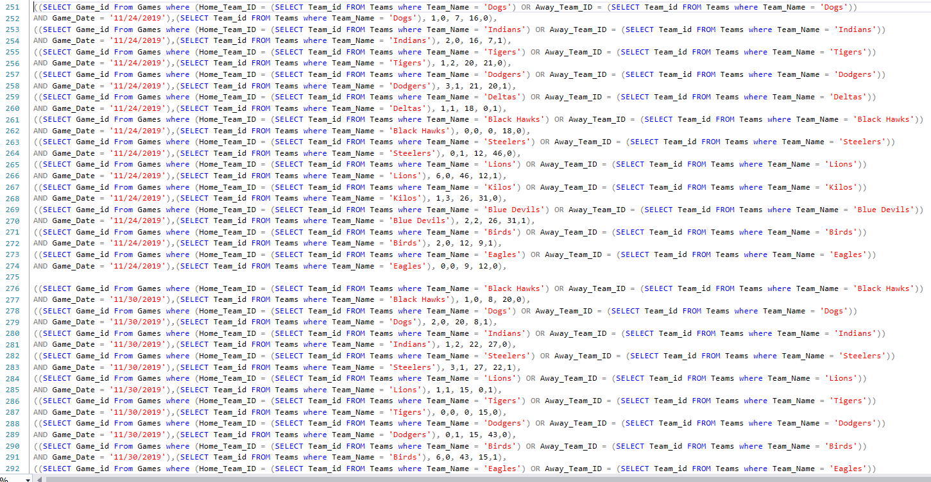

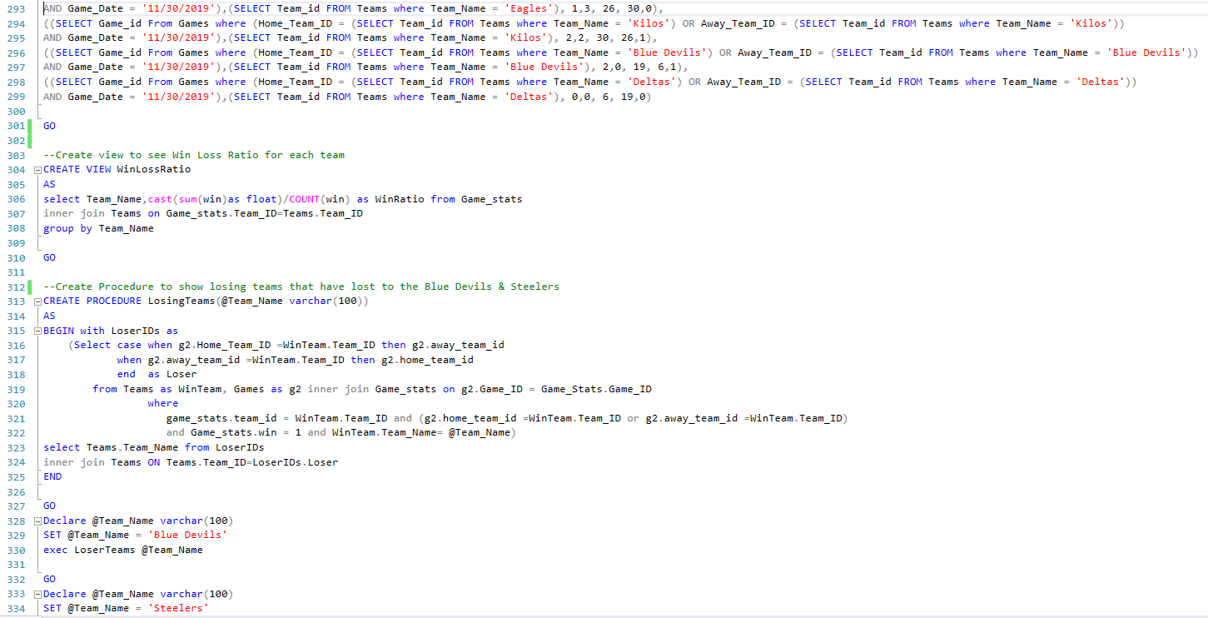

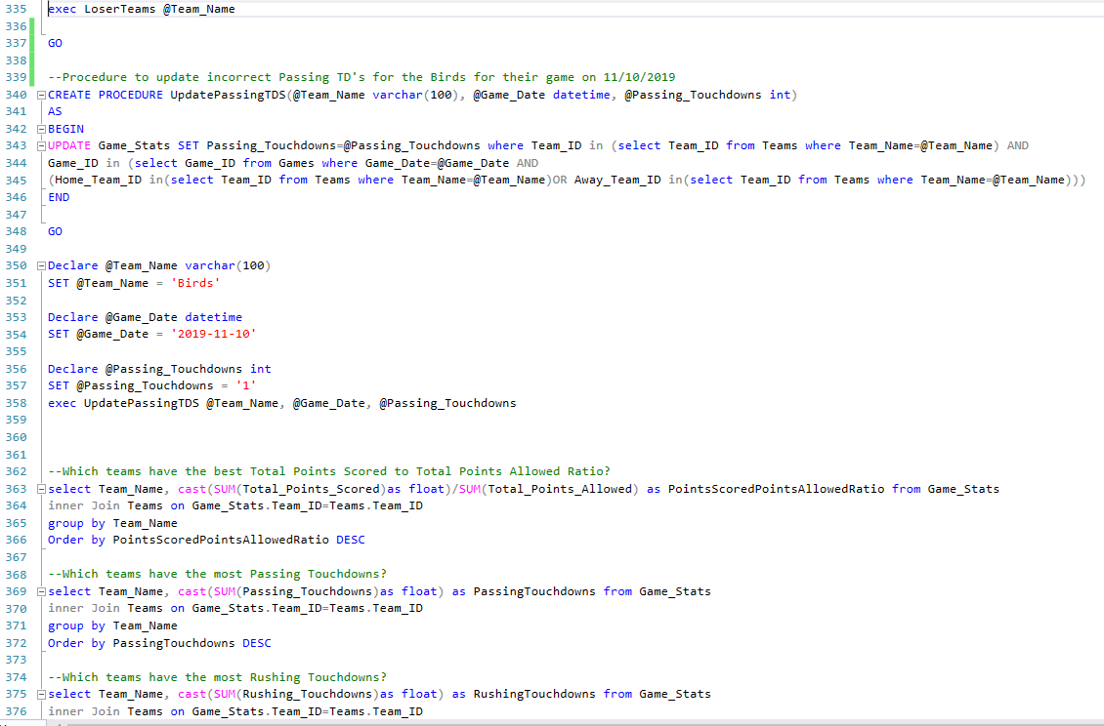

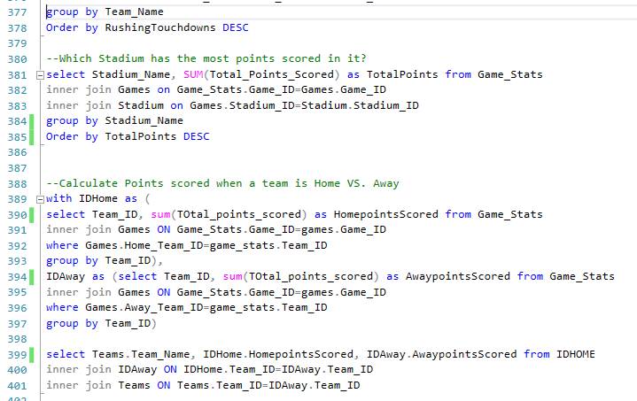

**--Copied from SQL**

--create tables/views/procedures/functions in repeatable form

-- create drops

--drop procedures

IF OBJECT_ID('dbo.LosingTeams') IS NOT NULL

DROP PROCEDURE dbo.LosingTeams

GO

IF OBJECT_ID('dbo.UpdatePassingTDS') IS NOT NULL

DROP PROCEDURE UpdatePassingTDS

--drop views

IF OBJECT_ID('dbo.WinLossRatio') IS NOT NULL

DROP VIEW dbo.WinLossRatio

--drop tables

IF OBJECT_ID('Game_Stats') IS NOT NULL

DROP TABLE dbo.Game_Stats

GO

IF OBJECT_ID('dbo.Games') IS NOT NULL

DROP TABLE dbo.Games

GO

IF OBJECT_ID('dbo.Stadium') IS NOT NULL

DROP TABLE dbo.Stadium

GO

IF OBJECT_ID('dbo.Teams') IS NOT NULL

DROP TABLE dbo.Teams

GO

---------------------------------------------------------------------------------

--create database tables

CREATE TABLE Teams(

--create columns

Team_ID int identity

, Team_Name varchar(50) NOT NULL unique

--place constraints

, CONSTRAINT PK_Team_ID PRIMARY KEY (Team_ID)

)

GO

CREATE TABLE Stadium(

--create columns

Stadium_ID int identity

,Stadium_Name varchar(50)

--place constraints

, CONSTRAINT PK_Stadium PRIMARY KEY (Stadium_ID)

)

GO

CREATE TABLE Games(

--create columns

Game_ID int identity

, Home_Team_ID int

, Away_Team_ID int

, Stadium_ID int

,Game_Date datetime

--place constraints

, CONSTRAINT PF_Games Primary KEY(Game_ID)

, CONSTRAINT FK_Games FOREIGN KEY(Home_Team_ID) REFERENCES Teams(Team_ID)

, CONSTRAINT FK2_Games FOREIGN KEY(Away_Team_ID) REFERENCES Teams(Team_ID)

, CONSTRAINT FK3_Games FOREIGN KEY(Stadium_ID) REFERENCES Stadium(Stadium_ID)

)

GO

CREATE TABLE Game_Stats(

--create columns

Game_ID int

, Team_ID int

, Rushing_Touchdowns int

, Passing_Touchdowns int

, Total_Points_Scored int

, Total_Points_Allowed int

, Win int

-- place constraints

, CONSTRAINT PF1_Games Foreign KEY(Game_ID) REFERENCES Games(Game_ID)

, CONSTRAINT FK1_Teams Foreign KEY(Team_ID) REFERENCES Teams(Team_ID)

, CONSTRAINT NonNegativeRushingTD Check (Rushing_Touchdowns > -1)

, CONSTRAINT NonNegativePassingTD Check (Passing_Touchdowns > -1)

, CONSTRAINT NonNegativeTotalPtsScored Check (Total_Points_Scored > -1)

, CONSTRAINT NonNegativeTotalPtsAllowed Check (Total_Points_Allowed > -1)

)

--Select * from Stadium

--Select * from Teams

--Select * from Games

--Select * from Game_Stats

GO

--insert Teams into Teams table

INSERT INTO Teams(Team_Name)

VALUES

('Eagles'),

('Blue Devils'),

('Black Hawks'),

('Dodgers'),

('Dogs'),

('Tigers'),

('Indians'),

('Lions'),

('Kilos'),

('Deltas'),

('Steelers'),

('Birds')

GO

--insert stadium info

INSERT INTO Stadium(Stadium_Name)

VALUES

('mastercard Stadium'),

('maestro Stadium'),

('visa Stadium'),

('diners-club-enroute Stadium'),

('china-unionpay Stadium'),

('visa-electron Stadium'),

('americanexpress Stadium'),

('diners-club-international Stadium'),

('solo Stadium'),

('laser Stadium'),

('instapayment Stadium'),

('bankcard Stadium')

GO

--insert Game info

INSERT INTO Games(Home_Team_ID, Away_Team_ID, Stadium_ID, Game_Date)

VALUES

((SELECT Team_id FROM Teams where Team_Name = 'Birds'), (SELECT Team_id FROM Teams where Team_Name ='Blue Devils'),

(SELECT Stadium_ID FROM Stadium where Stadium_Name = 'instapayment Stadium'),'11/10/2019'),

((SELECT Team_id FROM Teams where Team_Name = 'Dogs'), (SELECT Team_id FROM Teams where Team_Name ='Eagles'),

(SELECT Stadium_ID FROM Stadium where Stadium_Name = 'bankcard Stadium'),'11/10/2019'),

((SELECT Team_id FROM Teams where Team_Name = 'Tigers'), (SELECT Team_id FROM Teams where Team_Name ='Indians'),

(SELECT Stadium_ID FROM Stadium where Stadium_Name = 'laser Stadium'),'11/10/2019'),

((SELECT Team_id FROM Teams where Team_Name = 'Deltas'), (SELECT Team_id FROM Teams where Team_Name ='Dodgers'),

(SELECT Stadium_ID FROM Stadium where Stadium_Name = 'solo Stadium'),'11/10/2019'),

((SELECT Team_id FROM Teams where Team_Name = 'Steelers'), (SELECT Team_id FROM Teams where Team_Name ='Black Hawks'),

(SELECT Stadium_ID FROM Stadium where Stadium_Name = 'diners-club-international Stadium'),'11/10/2019'),

((SELECT Team_id FROM Teams where Team_Name = 'Kilos'), (SELECT Team_id FROM Teams where Team_Name ='Lions'),

(SELECT Stadium_ID FROM Stadium where Stadium_Name = 'americanexpress Stadium'),'11/10/2019'),

((SELECT Team_id FROM Teams where Team_Name = 'Blue Devils'), (SELECT Team_id FROM Teams where Team_Name ='Dogs'),

(SELECT Stadium_ID FROM Stadium where Stadium_Name = 'visa-electron Stadium'),'11/17/2019'),

((SELECT Team_id FROM Teams where Team_Name = 'Eagles'), (SELECT Team_id FROM Teams where Team_Name ='Tigers'),

(SELECT Stadium_ID FROM Stadium where Stadium_Name = 'china-unionpay Stadium'),'11/17/2019'),

((SELECT Team_id FROM Teams where Team_Name = 'Indians'), (SELECT Team_id FROM Teams where Team_Name ='Deltas'),

(SELECT Stadium_ID FROM Stadium where Stadium_Name = 'diners-club-enroute Stadium'),'11/17/2019'),

((SELECT Team_id FROM Teams where Team_Name = 'Dodgers'), (SELECT Team_id FROM Teams where Team_Name ='Steelers'),

(SELECT Stadium_ID FROM Stadium where Stadium_Name = 'visa Stadium'),'11/17/2019'),

((SELECT Team_id FROM Teams where Team_Name = 'Black Hawks'), (SELECT Team_id FROM Teams where Team_Name ='Kilos'),

(SELECT Stadium_ID FROM Stadium where Stadium_Name = 'maestro Stadium'),'11/17/2019'),

((SELECT Team_id FROM Teams where Team_Name = 'Lions'), (SELECT Team_id FROM Teams where Team_Name ='Birds'),

(SELECT Stadium_ID FROM Stadium where Stadium_Name = 'mastercard Stadium'),'11/17/2019'),

((SELECT Team_id FROM Teams where Team_Name = 'Dogs'), (SELECT Team_id FROM Teams where Team_Name ='Indians'),

(SELECT Stadium_ID FROM Stadium where Stadium_Name = 'bankcard Stadium'),'11/24/2019'),

((SELECT Team_id FROM Teams where Team_Name = 'Tigers'), (SELECT Team_id FROM Teams where Team_Name ='Dodgers'),

(SELECT Stadium_ID FROM Stadium where Stadium_Name = 'laser Stadium'),'11/24/2019'),

((SELECT Team_id FROM Teams where Team_Name = 'Deltas'), (SELECT Team_id FROM Teams where Team_Name ='Black Hawks'),

(SELECT Stadium_ID FROM Stadium where Stadium_Name = 'solo Stadium'),'11/24/2019'),

((SELECT Team_id FROM Teams where Team_Name = 'Steelers'), (SELECT Team_id FROM Teams where Team_Name ='Lions'),

(SELECT Stadium_ID FROM Stadium where Stadium_Name = 'diners-club-international Stadium'),'11/24/2019'),

((SELECT Team_id FROM Teams where Team_Name = 'Kilos'), (SELECT Team_id FROM Teams where Team_Name ='Blue Devils'),

(SELECT Stadium_ID FROM Stadium where Stadium_Name = 'americanexpress Stadium'),'11/24/2019'),

((SELECT Team_id FROM Teams where Team_Name = 'Birds'), (SELECT Team_id FROM Teams where Team_Name ='Eagles'),

(SELECT Stadium_ID FROM Stadium where Stadium_Name = 'instapayment Stadium'),'11/24/2019'),

((SELECT Team_id FROM Teams where Team_Name = 'Black Hawks'), (SELECT Team_id FROM Teams where Team_Name ='Dogs'),

(SELECT Stadium_ID FROM Stadium where Stadium_Name = 'maestro Stadium'),'11/30/2019'),

((SELECT Team_id FROM Teams where Team_Name = 'Indians'), (SELECT Team_id FROM Teams where Team_Name ='Steelers'),

(SELECT Stadium_ID FROM Stadium where Stadium_Name = 'diners-club-enroute Stadium'),'11/30/2019'),

((SELECT Team_id FROM Teams where Team_Name = 'Lions'), (SELECT Team_id FROM Teams where Team_Name ='Tigers'),

(SELECT Stadium_ID FROM Stadium where Stadium_Name = 'mastercard Stadium'),'11/30/2019'),

((SELECT Team_id FROM Teams where Team_Name = 'Dodgers'), (SELECT Team_id FROM Teams where Team_Name ='Birds'),

(SELECT Stadium_ID FROM Stadium where Stadium_Name = 'visa Stadium'),'11/30/2019'),

((SELECT Team_id FROM Teams where Team_Name = 'Eagles'), (SELECT Team_id FROM Teams where Team_Name ='Kilos'),

(SELECT Stadium_ID FROM Stadium where Stadium_Name = 'china-unionpay Stadium'),'11/30/2019'),

((SELECT Team_id FROM Teams where Team_Name = 'Blue Devils'), (SELECT Team_id FROM Teams where Team_Name ='Deltas'),

(SELECT Stadium_ID FROM Stadium where Stadium_Name = 'visa-electron Stadium'),'11/30/2019')

GO

--insert Game Stats info

INSERT INTO Game_Stats(Game_ID,Team_ID, Rushing_Touchdowns, Passing_Touchdowns, Total_Points_Scored, Total_Points_Allowed, Win)

VALUES

((SELECT Game_id From Games where (Home_Team_ID = (SELECT Team_id FROM Teams where Team_Name = 'Birds') OR Away_Team_ID = (SELECT Team_id FROM Teams where Team_Name = 'Birds'))

AND Game_Date = '11/10/2019') ,(SELECT Team_id FROM Teams where Team_Name = 'Birds'), 4,0, 32, 45,0),

((SELECT Game_id From Games where (Home_Team_ID = (SELECT Team_id FROM Teams where Team_Name = 'Blue Devils') OR Away_Team_ID = (SELECT Team_id FROM Teams where Team_Name = 'Blue Devils'))

AND Game_Date = '11/10/2019') ,(SELECT Team_id FROM Teams where Team_Name = 'Blue Devils'), 3,3, 45, 32,1),

((SELECT Game_id From Games where (Home_Team_ID = (SELECT Team_id FROM Teams where Team_Name = 'Dogs') OR Away_Team_ID = (SELECT Team_id FROM Teams where Team_Name = 'Dogs'))

AND Game_Date = '11/10/2019') ,(SELECT Team_id FROM Teams where Team_Name = 'Dogs'), 1,1, 14, 7,1),

((SELECT Game_id From Games where (Home_Team_ID = (SELECT Team_id FROM Teams where Team_Name = 'Eagles') OR Away_Team_ID = (SELECT Team_id FROM Teams where Team_Name = 'Eagles'))

AND Game_Date = '11/10/2019') ,(SELECT Team_id FROM Teams where Team_Name = 'Eagles'), 0,1, 7, 14,0),

((SELECT Game_id From Games where (Home_Team_ID = (SELECT Team_id FROM Teams where Team_Name = 'Tigers') OR Away_Team_ID = (SELECT Team_id FROM Teams where Team_Name = 'Tigers'))

AND Game_Date = '11/10/2019') ,(SELECT Team_id FROM Teams where Team_Name = 'Tigers'), 2,2, 27, 24,1),

((SELECT Game_id From Games where (Home_Team_ID = (SELECT Team_id FROM Teams where Team_Name = 'Indians') OR Away_Team_ID = (SELECT Team_id FROM Teams where Team_Name = 'Indians'))

AND Game_Date = '11/10/2019') ,(SELECT Team_id FROM Teams where Team_Name = 'Indians'), 1,2, 24, 27,0),

((SELECT Game_id From Games where (Home_Team_ID = (SELECT Team_id FROM Teams where Team_Name = 'Deltas') OR Away_Team_ID = (SELECT Team_id FROM Teams where Team_Name = 'Deltas'))

AND Game_Date = '11/10/2019') ,(SELECT Team_id FROM Teams where Team_Name = 'Deltas'), 2,3, 42, 45,0),

((SELECT Game_id From Games where (Home_Team_ID = (SELECT Team_id FROM Teams where Team_Name = 'Dodgers') OR Away_Team_ID = (SELECT Team_id FROM Teams where Team_Name = 'Dodgers'))

AND Game_Date = '11/10/2019') ,(SELECT Team_id FROM Teams where Team_Name = 'Dodgers'), 4,1, 45, 42,1),

((SELECT Game_id From Games where (Home_Team_ID = (SELECT Team_id FROM Teams where Team_Name = 'Steelers') OR Away_Team_ID = (SELECT Team_id FROM Teams where Team_Name = 'Steelers'))

AND Game_Date = '11/10/2019') ,(SELECT Team_id FROM Teams where Team_Name = 'Steelers'), 1,0, 10, 0,1),

((SELECT Game_id From Games where (Home_Team_ID = (SELECT Team_id FROM Teams where Team_Name = 'Black Hawks') OR Away_Team_ID = (SELECT Team_id FROM Teams where Team_Name = 'Black Hawks'))

AND Game_Date = '11/10/2019') ,(SELECT Team_id FROM Teams where Team_Name = 'Black Hawks'), 0,1, 0, 10,0),

((SELECT Game_id From Games where (Home_Team_ID = (SELECT Team_id FROM Teams where Team_Name = 'Kilos') OR Away_Team_ID = (SELECT Team_id FROM Teams where Team_Name = 'Kilos'))

AND Game_Date = '11/10/2019') ,(SELECT Team_id FROM Teams where Team_Name = 'Kilos'), 3,2, 38, 35,1),

((SELECT Game_id From Games where (Home_Team_ID = (SELECT Team_id FROM Teams where Team_Name = 'Lions') OR Away_Team_ID = (SELECT Team_id FROM Teams where Team_Name = 'Lions'))

AND Game_Date = '11/10/2019') ,(SELECT Team_id FROM Teams where Team_Name = 'Lions'), 0,5, 35, 38,0),

((SELECT Game_id From Games where (Home_Team_ID = (SELECT Team_id FROM Teams where Team_Name = 'Blue Devils') OR Away_Team_ID = (SELECT Team_id FROM Teams where Team_Name = 'Blue Devils'))

AND Game_Date = '11/17/2019'),(SELECT Team_id FROM Teams where Team_Name = 'Blue Devils'), 1,0, 10, 17,0),

((SELECT Game_id From Games where (Home_Team_ID = (SELECT Team_id FROM Teams where Team_Name = 'Dogs') OR Away_Team_ID = (SELECT Team_id FROM Teams where Team_Name = 'Dogs'))

AND Game_Date = '11/17/2019'),(SELECT Team_id FROM Teams where Team_Name = 'Dogs'), 2,0, 17, 10,1),

((SELECT Game_id From Games where (Home_Team_ID = (SELECT Team_id FROM Teams where Team_Name = 'Eagles') OR Away_Team_ID = (SELECT Team_id FROM Teams where Team_Name = 'Eagles'))

AND Game_Date = '11/17/2019'),(SELECT Team_id FROM Teams where Team_Name = 'Eagles'), 1,2, 23, 26,0),

((SELECT Game_id From Games where (Home_Team_ID = (SELECT Team_id FROM Teams where Team_Name = 'Tigers') OR Away_Team_ID = (SELECT Team_id FROM Teams where Team_Name = 'Tigers'))

AND Game_Date = '11/17/2019'),(SELECT Team_id FROM Teams where Team_Name = 'Tigers'), 3,1, 26, 23,1),

((SELECT Game_id From Games where (Home_Team_ID = (SELECT Team_id FROM Teams where Team_Name = 'Indians') OR Away_Team_ID = (SELECT Team_id FROM Teams where Team_Name = 'Indians'))

AND Game_Date = '11/17/2019'),(SELECT Team_id FROM Teams where Team_Name = 'Indians'), 1,1, 14, 0,1),

((SELECT Game_id From Games where (Home_Team_ID = (SELECT Team_id FROM Teams where Team_Name = 'Deltas') OR Away_Team_ID = (SELECT Team_id FROM Teams where Team_Name = 'Deltas'))

AND Game_Date = '11/17/2019'),(SELECT Team_id FROM Teams where Team_Name = 'Deltas'), 0,0, 0, 14,0),

((SELECT Game_id From Games where (Home_Team_ID = (SELECT Team_id FROM Teams where Team_Name = 'Dodgers') OR Away_Team_ID = (SELECT Team_id FROM Teams where Team_Name = 'Dodgers'))

AND Game_Date = '11/17/2019'),(SELECT Team_id FROM Teams where Team_Name = 'Dodgers'), 0,1, 6, 42,0),

((SELECT Game_id From Games where (Home_Team_ID = (SELECT Team_id FROM Teams where Team_Name = 'Steelers') OR Away_Team_ID = (SELECT Team_id FROM Teams where Team_Name = 'Steelers'))

AND Game_Date = '11/17/2019'),(SELECT Team_id FROM Teams where Team_Name = 'Steelers'), 6,0, 42, 6,1),

((SELECT Game_id From Games where (Home_Team_ID = (SELECT Team_id FROM Teams where Team_Name = 'Black Hawks') OR Away_Team_ID = (SELECT Team_id FROM Teams where Team_Name = 'Black Hawks'))

AND Game_Date = '11/17/2019'),(SELECT Team_id FROM Teams where Team_Name = 'Black Hawks'), 1,3, 24, 27,0),

((SELECT Game_id From Games where (Home_Team_ID = (SELECT Team_id FROM Teams where Team_Name = 'Kilos') OR Away_Team_ID = (SELECT Team_id FROM Teams where Team_Name = 'Kilos'))

AND Game_Date = '11/17/2019'),(SELECT Team_id FROM Teams where Team_Name = 'Kilos'), 2,2, 27, 24,1),

((SELECT Game_id From Games where (Home_Team_ID = (SELECT Team_id FROM Teams where Team_Name = 'Lions') OR Away_Team_ID = (SELECT Team_id FROM Teams where Team_Name = 'Lions'))

AND Game_Date = '11/17/2019'),(SELECT Team_id FROM Teams where Team_Name = 'Lions'), 2,0, 14, 3,1),

((SELECT Game_id From Games where (Home_Team_ID = (SELECT Team_id FROM Teams where Team_Name = 'Birds') OR Away_Team_ID = (SELECT Team_id FROM Teams where Team_Name = 'Birds'))

AND Game_Date = '11/17/2019'),(SELECT Team_id FROM Teams where Team_Name = 'Birds'), 0,0, 3, 14,0),

((SELECT Game_id From Games where (Home_Team_ID = (SELECT Team_id FROM Teams where Team_Name = 'Dogs') OR Away_Team_ID = (SELECT Team_id FROM Teams where Team_Name = 'Dogs'))

AND Game_Date = '11/24/2019'),(SELECT Team_id FROM Teams where Team_Name = 'Dogs'), 1,0, 7, 16,0),

((SELECT Game_id From Games where (Home_Team_ID = (SELECT Team_id FROM Teams where Team_Name = 'Indians') OR Away_Team_ID = (SELECT Team_id FROM Teams where Team_Name = 'Indians'))

AND Game_Date = '11/24/2019'),(SELECT Team_id FROM Teams where Team_Name = 'Indians'), 2,0, 16, 7,1),

((SELECT Game_id From Games where (Home_Team_ID = (SELECT Team_id FROM Teams where Team_Name = 'Tigers') OR Away_Team_ID = (SELECT Team_id FROM Teams where Team_Name = 'Tigers'))

AND Game_Date = '11/24/2019'),(SELECT Team_id FROM Teams where Team_Name = 'Tigers'), 1,2, 20, 21,0),

((SELECT Game_id From Games where (Home_Team_ID = (SELECT Team_id FROM Teams where Team_Name = 'Dodgers') OR Away_Team_ID = (SELECT Team_id FROM Teams where Team_Name = 'Dodgers'))

AND Game_Date = '11/24/2019'),(SELECT Team_id FROM Teams where Team_Name = 'Dodgers'), 3,1, 21, 20,1),

((SELECT Game_id From Games where (Home_Team_ID = (SELECT Team_id FROM Teams where Team_Name = 'Deltas') OR Away_Team_ID = (SELECT Team_id FROM Teams where Team_Name = 'Deltas'))

AND Game_Date = '11/24/2019'),(SELECT Team_id FROM Teams where Team_Name = 'Deltas'), 1,1, 18, 0,1),

((SELECT Game_id From Games where (Home_Team_ID = (SELECT Team_id FROM Teams where Team_Name = 'Black Hawks') OR Away_Team_ID = (SELECT Team_id FROM Teams where Team_Name = 'Black Hawks'))

AND Game_Date = '11/24/2019'),(SELECT Team_id FROM Teams where Team_Name = 'Black Hawks'), 0,0, 0, 18,0),

((SELECT Game_id From Games where (Home_Team_ID = (SELECT Team_id FROM Teams where Team_Name = 'Steelers') OR Away_Team_ID = (SELECT Team_id FROM Teams where Team_Name = 'Steelers'))

AND Game_Date = '11/24/2019'),(SELECT Team_id FROM Teams where Team_Name = 'Steelers'), 0,1, 12, 46,0),

((SELECT Game_id From Games where (Home_Team_ID = (SELECT Team_id FROM Teams where Team_Name = 'Lions') OR Away_Team_ID = (SELECT Team_id FROM Teams where Team_Name = 'Lions'))

AND Game_Date = '11/24/2019'),(SELECT Team_id FROM Teams where Team_Name = 'Lions'), 6,0, 46, 12,1),

((SELECT Game_id From Games where (Home_Team_ID = (SELECT Team_id FROM Teams where Team_Name = 'Kilos') OR Away_Team_ID = (SELECT Team_id FROM Teams where Team_Name = 'Kilos'))

AND Game_Date = '11/24/2019'),(SELECT Team_id FROM Teams where Team_Name = 'Kilos'), 1,3, 26, 31,0),

((SELECT Game_id From Games where (Home_Team_ID = (SELECT Team_id FROM Teams where Team_Name = 'Blue Devils') OR Away_Team_ID = (SELECT Team_id FROM Teams where Team_Name = 'Blue Devils'))

AND Game_Date = '11/24/2019'),(SELECT Team_id FROM Teams where Team_Name = 'Blue Devils'), 2,2, 26, 31,1),

((SELECT Game_id From Games where (Home_Team_ID = (SELECT Team_id FROM Teams where Team_Name = 'Birds') OR Away_Team_ID = (SELECT Team_id FROM Teams where Team_Name = 'Birds'))

AND Game_Date = '11/24/2019'),(SELECT Team_id FROM Teams where Team_Name = 'Birds'), 2,0, 12, 9,1),

((SELECT Game_id From Games where (Home_Team_ID = (SELECT Team_id FROM Teams where Team_Name = 'Eagles') OR Away_Team_ID = (SELECT Team_id FROM Teams where Team_Name = 'Eagles'))

AND Game_Date = '11/24/2019'),(SELECT Team_id FROM Teams where Team_Name = 'Eagles'), 0,0, 9, 12,0),

((SELECT Game_id From Games where (Home_Team_ID = (SELECT Team_id FROM Teams where Team_Name = 'Black Hawks') OR Away_Team_ID = (SELECT Team_id FROM Teams where Team_Name = 'Black Hawks'))

AND Game_Date = '11/30/2019'),(SELECT Team_id FROM Teams where Team_Name = 'Black Hawks'), 1,0, 8, 20,0),

((SELECT Game_id From Games where (Home_Team_ID = (SELECT Team_id FROM Teams where Team_Name = 'Dogs') OR Away_Team_ID = (SELECT Team_id FROM Teams where Team_Name = 'Dogs'))

AND Game_Date = '11/30/2019'),(SELECT Team_id FROM Teams where Team_Name = 'Dogs'), 2,0, 20, 8,1),

((SELECT Game_id From Games where (Home_Team_ID = (SELECT Team_id FROM Teams where Team_Name = 'Indians') OR Away_Team_ID = (SELECT Team_id FROM Teams where Team_Name = 'Indians'))

AND Game_Date = '11/30/2019'),(SELECT Team_id FROM Teams where Team_Name = 'Indians'), 1,2, 22, 27,0),

((SELECT Game_id From Games where (Home_Team_ID = (SELECT Team_id FROM Teams where Team_Name = 'Steelers') OR Away_Team_ID = (SELECT Team_id FROM Teams where Team_Name = 'Steelers'))

AND Game_Date = '11/30/2019'),(SELECT Team_id FROM Teams where Team_Name = 'Steelers'), 3,1, 27, 22,1),

((SELECT Game_id From Games where (Home_Team_ID = (SELECT Team_id FROM Teams where Team_Name = 'Lions') OR Away_Team_ID = (SELECT Team_id FROM Teams where Team_Name = 'Lions'))

AND Game_Date = '11/30/2019'),(SELECT Team_id FROM Teams where Team_Name = 'Lions'), 1,1, 15, 0,1),

((SELECT Game_id From Games where (Home_Team_ID = (SELECT Team_id FROM Teams where Team_Name = 'Tigers') OR Away_Team_ID = (SELECT Team_id FROM Teams where Team_Name = 'Tigers'))

AND Game_Date = '11/30/2019'),(SELECT Team_id FROM Teams where Team_Name = 'Tigers'), 0,0, 0, 15,0),

((SELECT Game_id From Games where (Home_Team_ID = (SELECT Team_id FROM Teams where Team_Name = 'Dodgers') OR Away_Team_ID = (SELECT Team_id FROM Teams where Team_Name = 'Dodgers'))

AND Game_Date = '11/30/2019'),(SELECT Team_id FROM Teams where Team_Name = 'Dodgers'), 0,1, 15, 43,0),

((SELECT Game_id From Games where (Home_Team_ID = (SELECT Team_id FROM Teams where Team_Name = 'Birds') OR Away_Team_ID = (SELECT Team_id FROM Teams where Team_Name = 'Birds'))

AND Game_Date = '11/30/2019'),(SELECT Team_id FROM Teams where Team_Name = 'Birds'), 6,0, 43, 15,1),

((SELECT Game_id From Games where (Home_Team_ID = (SELECT Team_id FROM Teams where Team_Name = 'Eagles') OR Away_Team_ID = (SELECT Team_id FROM Teams where Team_Name = 'Eagles'))

AND Game_Date = '11/30/2019'),(SELECT Team_id FROM Teams where Team_Name = 'Eagles'), 1,3, 26, 30,0),

((SELECT Game_id From Games where (Home_Team_ID = (SELECT Team_id FROM Teams where Team_Name = 'Kilos') OR Away_Team_ID = (SELECT Team_id FROM Teams where Team_Name = 'Kilos'))

AND Game_Date = '11/30/2019'),(SELECT Team_id FROM Teams where Team_Name = 'Kilos'), 2,2, 30, 26,1),

((SELECT Game_id From Games where (Home_Team_ID = (SELECT Team_id FROM Teams where Team_Name = 'Blue Devils') OR Away_Team_ID = (SELECT Team_id FROM Teams where Team_Name = 'Blue Devils'))

AND Game_Date = '11/30/2019'),(SELECT Team_id FROM Teams where Team_Name = 'Blue Devils'), 2,0, 19, 6,1),

((SELECT Game_id From Games where (Home_Team_ID = (SELECT Team_id FROM Teams where Team_Name = 'Deltas') OR Away_Team_ID = (SELECT Team_id FROM Teams where Team_Name = 'Deltas'))

AND Game_Date = '11/30/2019'),(SELECT Team_id FROM Teams where Team_Name = 'Deltas'), 0,0, 6, 19,0)

GO

--Create view to see Win Loss Ratio for each team

CREATE VIEW WinLossRatio

AS

select Team_Name,cast(sum(win)as float)/COUNT(win) as WinRatio from Game_stats

inner join Teams on Game_stats.Team_ID=Teams.Team_ID

group by Team_Name

GO

--Create Procedure to show losing teams that have lost to the Blue Devils & Steelers

CREATE PROCEDURE LosingTeams(@Team_Name varchar(100))

AS

BEGIN with LoserIDs as

(Select case when g2.Home_Team_ID =WinTeam.Team_ID then g2.away_team_id

when g2.away_team_id =WinTeam.Team_ID then g2.home_team_id

end as Loser

from Teams as WinTeam, Games as g2 inner join Game_stats on g2.Game_ID = Game_Stats.Game_ID

where

game_stats.team_id = WinTeam.Team_ID and (g2.home_team_id =WinTeam.Team_ID or g2.away_team_id =WinTeam.Team_ID)

and Game_stats.win = 1 and WinTeam.Team_Name= @Team_Name)

select Teams.Team_Name from LoserIDs

inner join Teams ON Teams.Team_ID=LoserIDs.Loser

END

GO

Declare @Team_Name varchar(100)

SET @Team_Name = 'Blue Devils'

exec LoserTeams @Team_Name

GO

Declare @Team_Name varchar(100)

SET @Team_Name = 'Steelers'

exec LoserTeams @Team_Name

GO

--Procedure to update incorrect Passing TD's for the Birds for their game on 11/10/2019

CREATE PROCEDURE UpdatePassingTDS(@Team_Name varchar(100), @Game_Date datetime, @Passing_Touchdowns int)

AS

BEGIN

UPDATE Game_Stats SET Passing_Touchdowns=@Passing_Touchdowns where Team_ID in (select Team_ID from Teams where Team_Name=@Team_Name) AND

Game_ID in (select Game_ID from Games where Game_Date=@Game_Date AND

(Home_Team_ID in(select Team_ID from Teams where Team_Name=@Team_Name)OR Away_Team_ID in(select Team_ID from Teams where Team_Name=@Team_Name)))

END

GO

Declare @Team_Name varchar(100)

SET @Team_Name = 'Birds'

Declare @Game_Date datetime

SET @Game_Date = '2019-11-10'

Declare @Passing_Touchdowns int

SET @Passing_Touchdowns = '1'

exec UpdatePassingTDS @Team_Name, @Game_Date, @Passing_Touchdowns

**--Which teams have the best Total Points Scored to Total Points Allowed Ratio?**

select Team_Name, cast(SUM(Total_Points_Scored)as float)/SUM(Total_Points_Allowed) as PointsScoredPointsAllowedRatio from Game_Stats

inner Join Teams on Game_Stats.Team_ID=Teams.Team_ID

group by Team_Name

Order by PointsScoredPointsAllowedRatio DESC

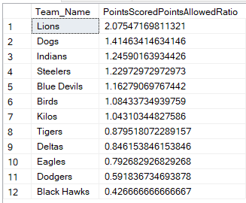

**--Which teams have the most Passing Touchdowns?**

select Team_Name, cast(SUM(Passing_Touchdowns)as float) as PassingTouchdowns from Game_Stats

inner Join Teams on Game_Stats.Team_ID=Teams.Team_ID

group by Team_Name

Order by PassingTouchdowns DESC

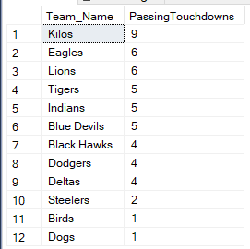

**--Which teams have the most Rushing Touchdowns?**

select Team_Name, cast(SUM(Rushing_Touchdowns)as float) as RushingTouchdowns from Game_Stats

inner Join Teams on Game_Stats.Team_ID=Teams.Team_ID

group by Team_Name

Order by RushingTouchdowns DESC

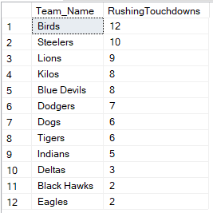

**--Which Stadium has the most points scored in it?**

select Stadium_Name, SUM(Total_Points_Scored) as TotalPoints from Game_Stats

inner join Games on Game_Stats.Game_ID=Games.Game_ID

inner join Stadium on Games.Stadium_ID=Stadium.Stadium_ID

group by Stadium_Name

Order by TotalPoints DESC

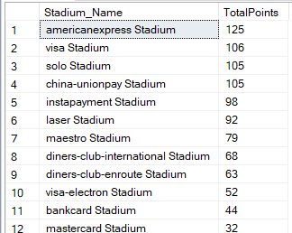

**--Calculate Points scored when a team is Home VS. Away**

with IDHome as (

select Team_ID, sum(TOtal_points_scored) as HomepointsScored from Game_Stats

inner join Games ON Game_Stats.Game_ID=games.Game_ID

where Games.Home_Team_ID=game_stats.Team_ID

group by Team_ID),

IDAway as (select Team_ID, sum(TOtal_points_scored) as AwaypointsScored from Game_Stats

inner join Games ON Game_Stats.Game_ID=games.Game_ID

where Games.Away_Team_ID=game_stats.Team_ID

group by Team_ID)

select Teams.Team_Name, IDHome.HomepointsScored, IDAway.AwaypointsScored from IDHOME

inner join IDAway ON IDHome.Team_ID=IDAway.Team_ID

inner join Teams ON Teams.Team_ID=IDAway.Team_ID

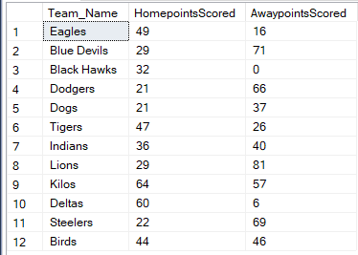

Linking my data to Access from SQL

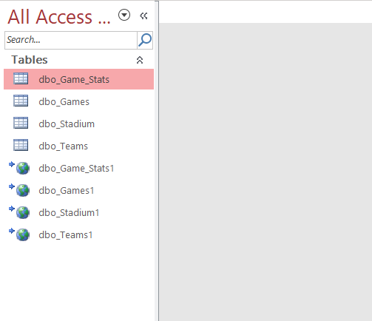

**Reflection**

At first, the Conceptual and Logical models were a struggle for me. My experience in SQL began by being thrown into coding without the background of Conceptual and Logical Models. I learned querying and data manipulation by trial and error without the necessary background needed. As the course progressed, modeling the tables and actually planning and thinking about organization became apparent to me how important it is. I think more time learning how to link SQL with Access and R would have been very beneficial. More time on these subjects would have allowed me to utilize more analysis tools. If I had another shot at this, I would have made my queries more efficient, as I realize many of mine are not written in the most efficient fashion. Again, more time learning about connections between SQL with Access and R would have been very beneficial.

**Summary**

Starting with the Conceptual and Logical modeling techniques was difficult for me in the beginning. As I mentioned before, I have had experience writing queries to extract and analyze data but as far as planning and organizing a database, I had not been accustomed to that. It provided me with a new perspective on how databases work and how efficiency is key to create a successful one. I was able to answer a majority of my questions through SQL queries, while also being able to create a few graphs in R. I am not a big fan of Access and would much rather use R to produce report outputs, as they are much more visually pleasing. I enjoyed working through this project learning how SQL, Access and R, as well as other languages, can vibe together and can be extremely beneficial in organizing and analyzing data.